The Rule of 2019 FIRA “RoboSot Race”

Version – 1.5

APPLICATION GROUP – TB3

DEVELOPMENT GROUP - OTHERS

**TASK**

Robot needs to find the balls and obstacles automatically with Camera and LiDar. Meanwhile, avoiding the obstacle and taking the ball to the specified area.

**RULES**

1. Every team is limited with one robot only. If A team signs up for application group and developed group, two robots must be prepared.
2. The “design” of the development group can’t be more than 50% similar to the TB3 platform or other commercial platform, who violated the rule will lose their qualifications after verification.
3. There will be 2 level of the game. Every team that score a minimum of 1 point in Level 1 will be eligible to enter the Level 2 game.
4. In Level 1:
   1. Every team will be given 3 trials. Each trial must be completed within 3 minutes.
   2. Robot must start from the start point in the middle point of the soccer field. Robot can be placed facing any direction.
   3. Referee will place 15 colored balls randomly in the field. The size of obstacles as shown in the Figure 3 below.
   4. Before the game start, referee will draw lots to decide the color of the challenge team. The designated color of each team may not be the same.
   5. Team will be given 2 minutes to prepare after the draw.
   6. Each robot must be fully autonomous in this competition. During the competition, human manipulation is not allowed, who violated the rule would be warned or deducted. Serious violation will cause the robot to be disqualified.
   7. The game start after referee whistles, robot must search the ball by themselves and push the ball into the corresponding color goal.
   8. A ball must be fully pushed over the goal line to be considered successful.
   9. Only the best score from the 3 trials will be counted for the total point.
5. In Level 2:
   1. the same as steps in 4 except 4(c) where referee will add 10 obstacles randomly in the field.
   2. Robot can’t touch any of the obstacle. Each hit will cause 1point deduction.
6. Participants are not allowed to hinder the competition or postpone the contest, which violated the rule seriously would lose their qualifications.
7. The Committee decision is final.
8. The organizer preserves the right of interpretation for the competition’s rule. There is no limitation in the way of the robot to push the ball. Every team can design their robots by themselves.

|  |
| --- |
|  |
| Fig. 1 Playing Field |

**Playing Field & Size Restrictions**

1. The playing field is the half of soccer field, as shown in the Figure 1.
2. The playing field size is 400 (L) x 300 (W) (mm).
3. The size of robot is limited to 180 (L) x 220 (W) x 240 (H) (mm) in development group.
4. It is allowed to add camera on TB3 platform in application group, but the size of robot cannot exceed 180 (L) x 220 (W) x 240 (H) (mm).

**Competition Objects**

1. The ball used is a baseball that comply with the International Major League Baseball rules.
2. The ball will be colored with the Dulux, America paint band. 5 colours will be used, red, black, blue, yellow and white. The color codes are as follow.

|  |  |  |  |  |
| --- | --- | --- | --- | --- |
| **Red** | **Black** | **Blue** | **Yellow** | **White** |
| 14/629 | 00NN 05/000 | 13BB 17/399 | 54YY 69/747 | Original |

1. Participants can use the color code to find the color what competition used in the website below: <https://www.dulux.com.hk/zh/colour-palettes>
2. The goal is divided into five areas as shown in the figure 2.
3. The obstacle size as shown in figure 3.

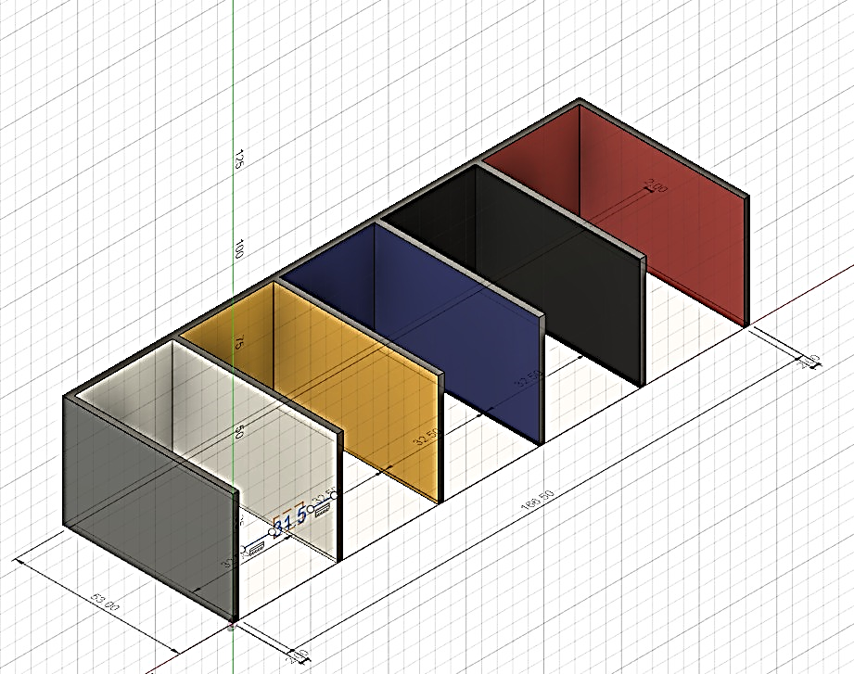

Fig. 2 The five area of the goal

|  |
| --- |
| Pyramid |
| Fig.3 The Obstacle |

**Score**

1. Designated color ball pushed into the correct color goal – 5 points
2. Other color balls pushed into the correct color goal – 3 points
3. Balls pushed into the wrong color goal – minus 1 point
4. Every obstacle touched – minus 1 point
5. The above conditions are judged by the referee.
6. Only the highest score from the 3 trials for each levels will be totaled.
7. Team with highest total score from Level 1 AND Level 2 wins.
8. If more than two team get the same score, a tiebreaker will commence.
9. Tiebreaker will consist of only 1 ball chosen and placed by referee with the fastest team to complete the task wins.